_{Hotel Continental} H_{C}

Project Documentation for
Hotel Management Software
Developed
by
Abbhinav Venkat

Indian School Bahrain
2012-2013

Table of Contents

Item No. | Contents | Page No.
I. | Objective | 3
II. | Features | 3
III. | Output | 4
IV. | Data Files Used | 4
V. | Program Flow Documentation | 5
 | 1. Welcome Screen | 5
 | 2. Login Screen with Password Validation | 6
 | 3. Main Menu | 7
 | 4. Booking Menu | 8
 | 5. Check-in Menu | 9
 | 6. Check-Out Menu | 10
 | 7. Cancellation Menu | 11
 | 8. Restaurant Service Menu | 12
 | 9. Taxi Service | 16
 | 10. Enquiry - Sub Menu | 17
 | 11. Booking Enquiry Sub-Menu | 18
 | 12. Check-in Enquiry Sub-Menu | 19
 | 13. Check-out Enquiry Sub-Menu | 20
 | 14. Cancellation Enquiry Sub-Menu | 21
 | 15. Rooms Occupancy Enquiry Sub-Menu | 22
 | 16. Create Bill | 23
 | 17. Exit Screen | 24
VI. | Format of Sample Outputs | 25
 | 1. Sample Guest Bill | 25
 | 2. Sample Taxi Service Request | 26

I. OBJECTIVE
The objective of this Hotel Management Project is to provide facilities for the Hotel reception to manage all the activities of guests from booking to check out. The software provides tools to manage the reservation in the hotel with appropriate security. The Hotel staff can easily check the availability of rooms & if the room is available, then it can be easily booked. The program has been developed in C++ and compiled using Turbo C++ Complier.

II. FEATURES
The project consists of the following main features:-
- Welcome Screen
- Login Screen with password maintenance
- Booking
- Check In
- Check Out
- Cancellation
- Restaurant Service
- Taxi Service
- Enquiry - Booking Information
- Enquiry - Check In Information
- Enquiry - Check Out Information
- Enquiry - Cancellation Information
- Enquiry - Rooms Availability
- Create Bill
- Exit - Thank You Screen

III. OUTPUTS
The items 9 to 13 above are Enquiry based options. They display outputs on the screen based on the nature of enquiry made.
The item 8, Taxi Service, is used to make bookings for taxi service. The output is stored in a text file TAXI.TXT, which then can be printed using any editor.
The item 14, Create Bill, generates the bill of the customer inclusive of all hotel charges and stores it in a text file BILL.TXT. The bill could then be printed using any editor.

IV. DATA FILES USED
The following files are used in the program:
- LOGINID.DAT to store User-id and Passwords
- BOOKED.DAT to store booking information
- CHECKIN.DAT to store Checked-in Information
- CHECKOUT.DAT to store Checked-out Information
- CANCEL.DAT to store Cancelled Information
- ROOMS.DAT to store rooms availability status
- TEMP.DAT for storing temporary data
- BILL.TXT stores the output of Bill created
- TAXI.TXT stores the output of Taxi booking

V. PROGRAM FLOW DOCUMENTATION

The flow of the program and each of the options along with the screens are detailed below.

1. Welcome Screen
Once the program is executed the software displays a WELCOME screen along with the name of Hotel as indicated below:
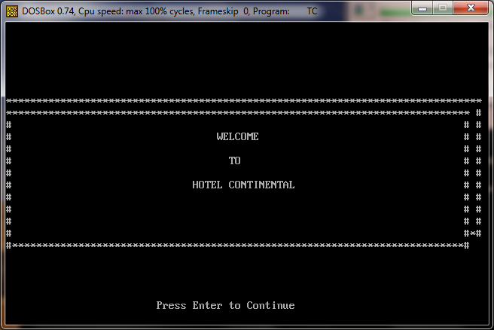

Once <Enter> key is pressed the software displays the Login Screen as indicated below.

2. Login Screen with Password Validation

The User-id and Passwords are predefined in the program and stored in the data file LOGINID.DAT. Five different User-Ids and Passwords are created. The software accepts only valid User-id and Password which are pre-defined. In case 3 continuous errors are made in either the User-id or the Password, the system would not allow access and the program would exit.

When User-id is keyed in, it is displayed on the screen, however the Password is not displayed in the screen at the time of input, only "*" is displayed so as to keep the password secure.

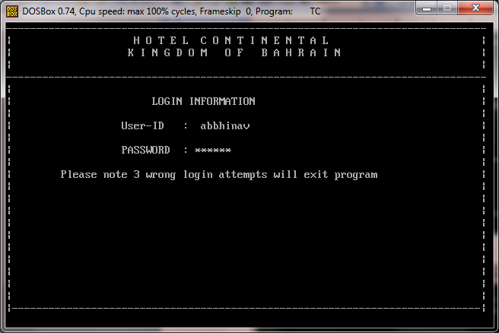

3. Main Menu

Once correct User-id and Password is provided, the software displays the Main Menu with options as indicated in screen below:
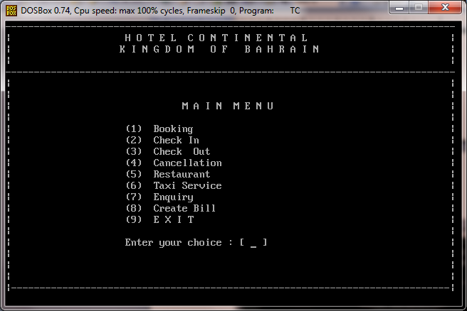

On choosing the option numbers indicated against each option, the program executes separate functions which are detailed below. After completion of execution of the functions, the program controls returns back to this main menu.

4. Booking Menu
On choosing option "1" from Main Menu, the software displays the Booking Screen as shown below. The value "Zero" could be entered in the Name field to return back to Main Menu without entering any other data.

The other details like Address, Telephone number and date of check-in are accepted using this option. Validation is done to check whether the date input is a valid date. The various Room types and their related codes and cost per day are displayed. The Room Code is accepted and based on their availability, room numbers are allotted. The availability of room is checked from the file ROOMS.DAT. If the rooms are not available the software displays an appropriate message.

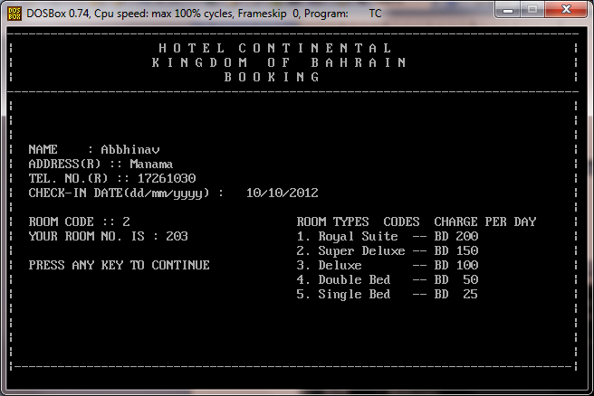

Once all the information is accepted the data is stored in the file BOOKING.DAT.

5. Check-In Menu
On choosing option "2" from Main Menu, the software displays the Check-In Screen as shown below. The software takes the input if the room has already been booked. If the answer is "N", the guest is not Booked and the control is returned back to the Main Menu.

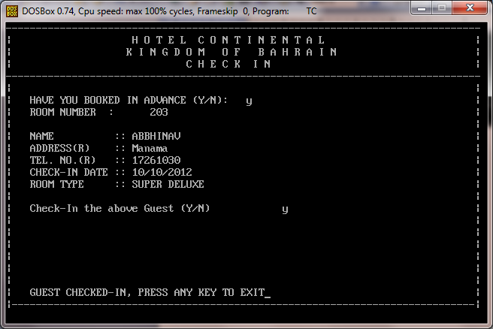

If the answer is "Y", the Rooms number is then accepted from the user. The room number input is checked as to whether it is available in the file BOOKING.DAT. If the data is not available, a message is displayed indicating that the Guest needs to be checked in first. If the data is available in the file BOOKING.DAT, the details related to this record (Name, Address, Telephone Number, Check-In Date and Room type) are displayed. A user confirmation is obtained whether to check in the Guest, if the answer is "Y" the data is updated in the file CHECKIN.DAT and record is deleted from BOOKING.DAT. The temporary data file TEMP.DAT is used in the updating process. If the answer is "N", no updating is done and the program returns to the Main Menu.
6. Check-Out Menu

On choosing option "3" from Main Menu, the software displays the Check-Out Screen as shown below.

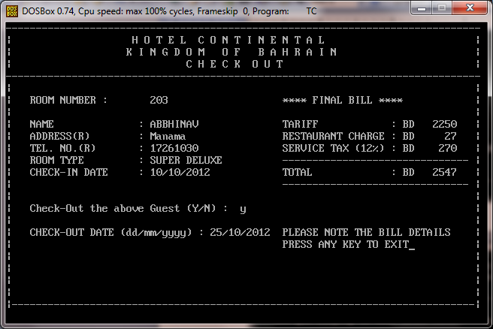

The software accepts the Room Number of the Guest to be checked out. It then validates the room number in the file CHECKIN.DAT and if the data is available, it displays the data of the Guest. The system takes the input whether the user would want to check out the Guest. If the input provided is "Y", the system takes a confirmation whether the bill has been printed, if not, the bill needs to be printed using the option CREATE BILL. On providing confirmation, the check-out date is accepted. The system then displays the Guest bill details on the screen. The data for the above Room number is deleted from the file CHECKIN.DAT.

7. Cancellation Menu

On choosing option "4" from Main Menu, the software displays the Cancellation Screen as shown below. The software accepts the Room number of the Guest and checks whether the record is available in the file BOOKING.DAT file. If the data is available, it displays the Guest details; if data is not available then an appropriate message is displayed.
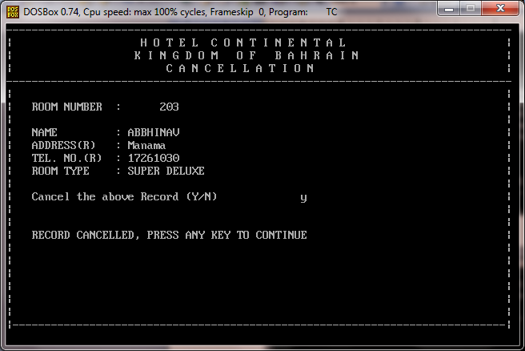

8. Restaurant Service Menu

On choosing option "5" from Main Menu, the software displays the Restaurant Menu card. In the first screen of the menu card the following are displayed:
- Vegetable varieties
- Raitha- Salad varieties
- Rice Varieties

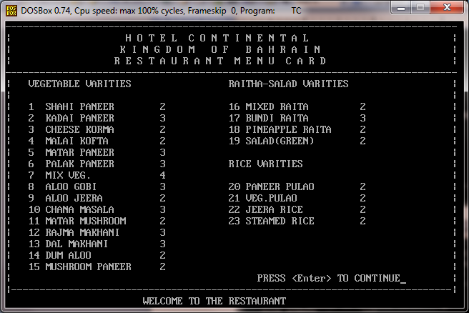

Once <Enter> key is pressed, it displays other menu items as under:
- Roti Naan Varieties
- Burger Sandwich Varieties
- Beverages

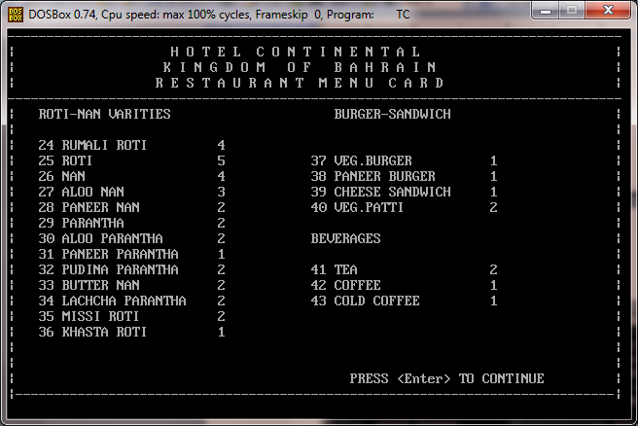

Once <Enter> key is pressed, it displays Ice Cream Varieties as per screen below:
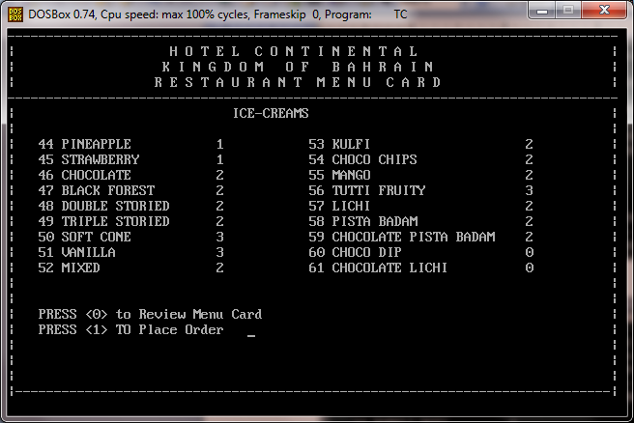
To review the menu card again, "0" is pressed and to place an order, "1" is pressed. On pressing "1", the Food code is accepted as input. Several items can be ordered; as the order is placed the software displays the items ordered from the restaurant along with their price. The placing of order can be stopped by pressing "0". Then the total of items for which the order is placed is displayed. The system takes an input whether the Guest stays in hotel. If the Guest is not staying in Hotel then the system displays a message according to which the guest has to pay the full amount in cash. If the Guest stays is staying in the Hotel, the system accepts the Room Number and validates the record in the file CHECKIN.DAT. If the record is available, the bill amount is updated in the record. If record is not available then the Guest needs to pay by Cash.

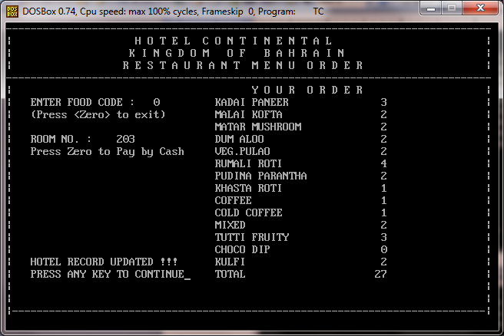

9. Taxi Service Menu

On choosing option "6" from Main Menu, the software displays the Taxi Service Request Screen as shown below. The software accepts the Room number as an input and validates if it is available in the file CHECKIN.DAT. If it is not available it provides a message that only checked in Guests can book for taxis. If the record is available, it displays the Guest details. It then takes an input as to when the taxi is required (date and time). A taxi service request is generated in the output file TAXI.DAT.

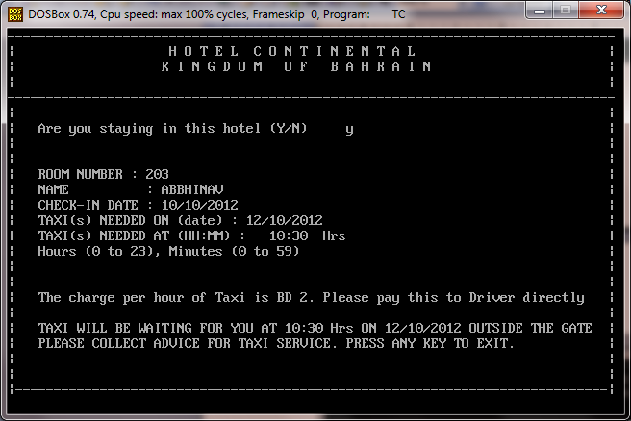

10. Enquiry Sub-Menu
On choosing option "7" from Main Menu, the software displays Enquiry Sub menu as per screen below. It has enquiry for the following data:
- Booking
- Checked in
- Check Out
- Cancelled
- Rooms Availability

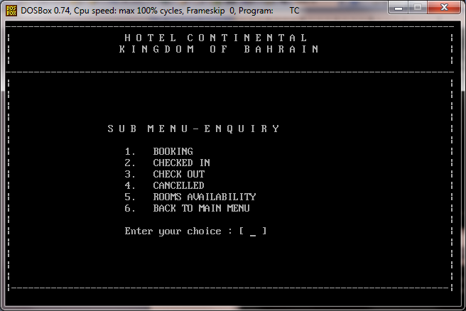

11. Booking Enquiry Sub-Menu
On choosing option "1" from Sub-Menu, the software displays the data of bookings made from the file BOOKING.DAT. In case all the records cannot be displayed in single screen, then multiple screens are used.

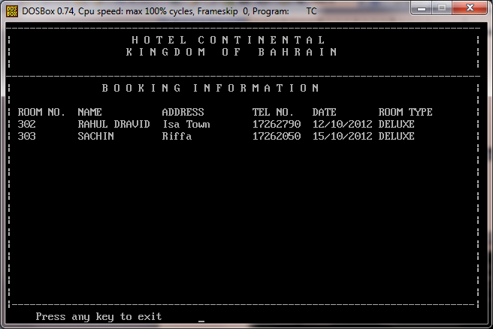

12. Check-in Enquiry Sub-Menu
On choosing option "2" from Sub-Menu, the software displays the data of customers checked in from the file CHECKIN.DAT. In case all the records cannot be displayed in single screen, then multiple screens are used.

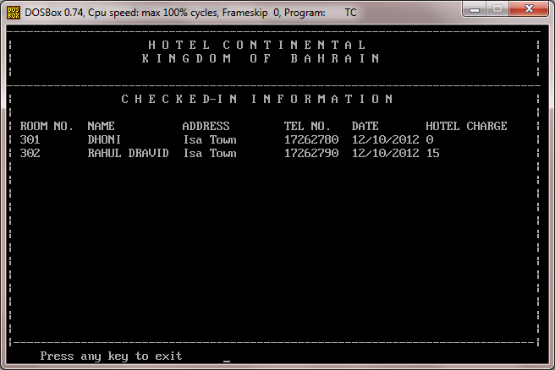

13. Check-Out Enquiry Sub-Menu
On choosing option "3" from Sub-Menu, the software displays the data of customers checked out from the file CHECKOUT.DAT. In case all the records cannot be displayed in a single screen, multiple screens are used.

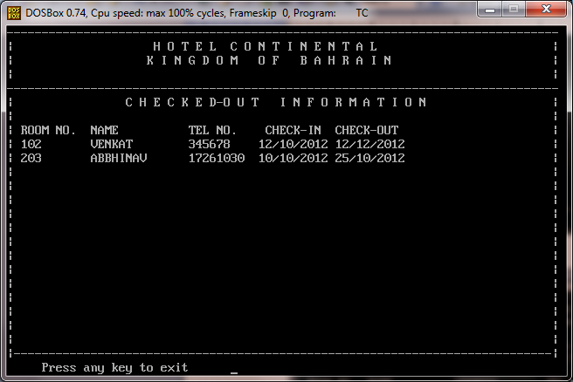

*-

14. Cancellation Enquiry Sub-Menu
On choosing option "4" from Sub-Menu, the software displays data of bookings cancelled from the file CANCEL.DAT. In case all the records cannot be displayed in a single screen, multiple screens are used.

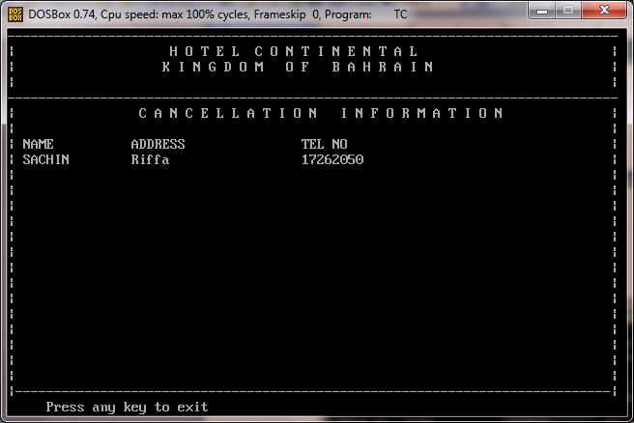

15. Rooms Occupancy Enquiry Sub-Menu
On choosing option "5" from Sub-Menu, the software displays data of the rooms available according to their room numbers from the file ROOMS.DAT. In case all the records cannot be displayed in a single screen, multiple screens are used.

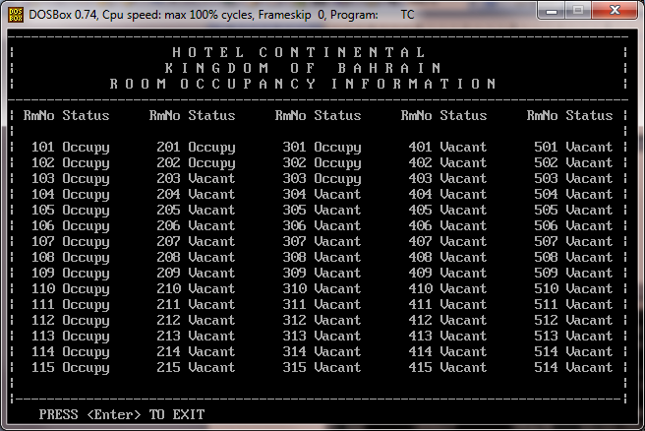

16. Create Bill Menu
On choosing option "8" from Main Menu, the software displays the Create Bill Screen as shown below. The software accepts the Room number of the Guest and checks whether the record is available in the file CHECKIN.DAT. If the record is not available, an appropriate error message is displayed. If the data is available, then it displays the Guest details. The software then accepts the checkout date. It then calculated the total amount due. The output is created in the file BILL.TXT which can be printed using an editor.

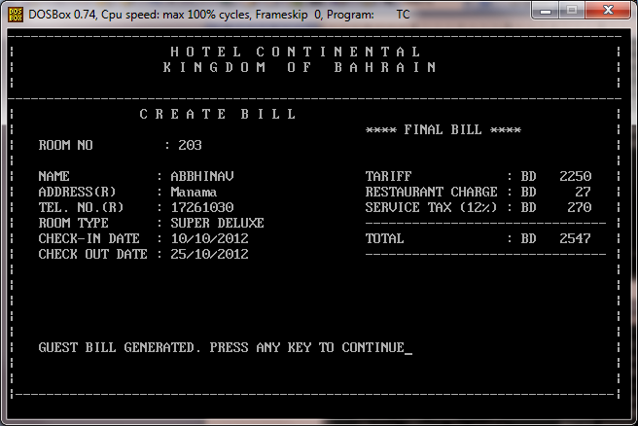

17. Exit Screen
On choosing option "9" from Main Menu, the software displays the Thank You Screen as shown below.
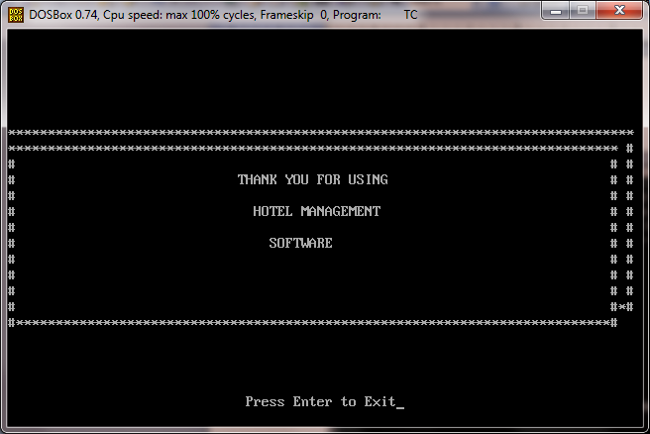

VI. Format of Output Generated

1. Sample Guest Bill

--------------------------------------------------------------------------------------------

H O T E L C O N T I N E N T A L
M A N A M A
K I N G D O M O F B A H R A I N

F I N A L B I L L
-------------------- ----

1. NAME : ABBHINAV
2. ADDRESS : Manama
3. TELEPHONE : 17261030

4. ROOM TYPE : SUPER DELUXE
5. CHECK IN DATE : 10/10/2012
6. CHECK OUT DATE : 25/10/2012
7. NO OF DAYS : 15

8. ROOM TARIFF : BD 2250
9. HOTEL CHARGES : BD 27
10. SERVICE CHARGES : BD 270

--------------------------------------------------------------------------------------
T O T A L : BD 2547
===============================================

THANK YOU FOR STAYING WITH US. PLEASE COME AGAIN.

--------------------------------------------------------------------------------------------

2. Sample Taxi Service Request

--------------------------------------------------------------------------------------------

H O T E L C O N T I N E N T A L
M A N A M A
K I N G D O M O F B A H R A I N

T A X I S E R V I C E
--------------------

1. NAME : ABBHINAV
2. ADDRESS : Manama
3. TELEPHONE : 17261030

4. ROOM TYPE : SUPER DELUXE
5. CHECK IN DATE : 10/10/2012
6. TAXI BOOKING DATE : 12/10/2012
7. BOOKING TIME : 10:30 Hrs

Contact Number for Taxi : 17-260399

The charge per hour of Taxi is BD 2. Please pay this to Driver directly

THANK YOU FOR BOOKING TAXI FROM US.
--------------------------------------------------------------------------------------------

Software Documentation for
Hotel Management System

H_{C}

